**COSC 483: COMPUTER SYSTEM PROJECT 2 REPORT**

# **UNI-TASK FREELANCER PLATFORM**

**Submitted to**

DR. CHARLES KINYUA GITONGA

DEPARTMENT OF COMPUTER SCIENCE

FACULTY OF SCIENCE ENGINEERING AND TECHNOLOGY

CHUKA UNIVERSITY

**Submitted by**

MUHIA LINCORN SAMUEL

EB1/56060/21

**On**

APRIL 2025

Declaration

I Muhia Lincorn Samuel declare that this project has not been submitted to any other University for the award of a Bachelor’s Degree in Computer Science.

Student Name: Muhia Lincorn Samuel

Sign: \_\_\_\_\_\_\_\_\_\_\_\_\_\_\_\_\_\_\_\_\_\_\_\_ Date: \_\_\_\_\_\_\_\_\_\_\_\_\_\_\_\_\_\_\_\_\_\_\_\_

## ****3. Certificate****

This is to certify that the project titled UniTask Freelancer Platform submitted by Muhia Licorn , Reg. No: EB1/56060/21, has been carried out under my supervision and meets the requirements for the award of a degree in Computer Science.

**Supervisor**: Dr Charles Kinyua  
**Signature**: \_\_\_\_\_\_\_\_\_\_\_\_\_\_\_\_\_\_\_\_  
**Date**: \_\_\_\_\_\_\_\_\_\_\_\_\_\_\_\_\_\_\_\_\_\_\_

**Abstract**

This project aims to develop Uni-Task Freelancer Platform, an innovative web-based application designed to connect freelancers with clients, offering a seamless and secure environment for job collaboration. Built using Angular for the frontend, Node.js for the backend, and MSSQL for database management, the platform addresses significant challenges in the freelancing ecosystem, including limited regional accessibility, trust deficits, and inefficiencies in project matching and payment processes.

A key feature of the platform is its smart job-matching algorithm, leveraging machine learning to pair freelancers and clients based on skills, project requirements, and past performance. The system also integrates secure payment gateways, user verification processes, and region-specific customization, ensuring a personalized and trustworthy user experience.

To enhance usability, the platform provides a responsive interface for both desktop and mobile devices, enabling efficient job posting, bidding, and tracking. Data security and ethical considerations are prioritized through robust encryption, role-based access control, and compliance with international data protection standards.

This project demonstrates the transformative potential of technology in creating an inclusive and efficient freelancing marketplace. By streamlining workflows and fostering trust, Uni-Task Freelancer Platform aims to empower global talent, reduce operational costs for businesses, and contribute to the growth of the gig economy, ensuring scalability and adaptability for future expansions.

## **CHAPTER 1: INTRODUCTION**

## **Background to the Study**

The gig economy is booming, yet many existing platforms lack transparency, are overly expensive, or provide limited control to freelancers and clients.

This study seeks to design and develop a comprehensive freelance job portal that overcomes these limitations. The portal aims to provide features that cater to a broad spectrum of industries and skill levels while emphasizing user-friendliness, affordability, and security.

## **1.2 Statement of the Problem**

There is a need for a streamlined, affordable platform where users can securely post, apply for, and complete freelance jobs.

**1.3 Objectives**

### **1.3.1 General Objective**

To design and develop a freelance job portal that bridges the gap between freelancers and employers, providing a secure, affordable, and user-friendly platform for collaboration.

### **1.3.2 Specific Objectives**

* To create a user registration and authentication system for freelancers and employers.
* To implement a comprehensive profile management feature for freelancers and employers.
* To create a platform for job posting and application.
* To create an inbuilt chat system between clients and freelancers
* To develop a secure payment gateway that ensures fair and timely transactions.
* To design a responsive and intuitive user interface accessible across devices.
* To analyze user feedback and iterate on platform features to ensure continuous improvement.

**1.4 Scope**

The platform includes authentication, job posting, bidding, ratings,a chat system and admin analytics.

**Chapter 2: Literature Review**

**Existing Solutions**

Platforms like Upwork and Fiverr dominate the freelance space but charge high commissions and offer limited customization for niche markets.

**Gaps Identified**

* High platform fees
* Inadequate user control

**Technologies/Tools Reviewed**

* Angular for UI
* Node.js and Express for API development
* Microsoft SQL Server for database management
* JSON Web Token (JWT) for authentication

**Chapter 3: Methodology**

**System Design Architecture**

Client-server architecture with REST APIs. Components include authentication, job modules, user dashboards, and admin panel.

**Tools**

Frontend: Angular

Backend: Node.js, Express

Database: MSSQL

Hosting: Localhost (development)

**Development Process**

This study employs an incremental methodology, a structured approach that breaks down the development process into manageable segments or increments. This methodology is particularly suited to projects requiring progressive elaboration, where core functionalities are developed, tested, and refined before adding more complex features.

**Database Design**

**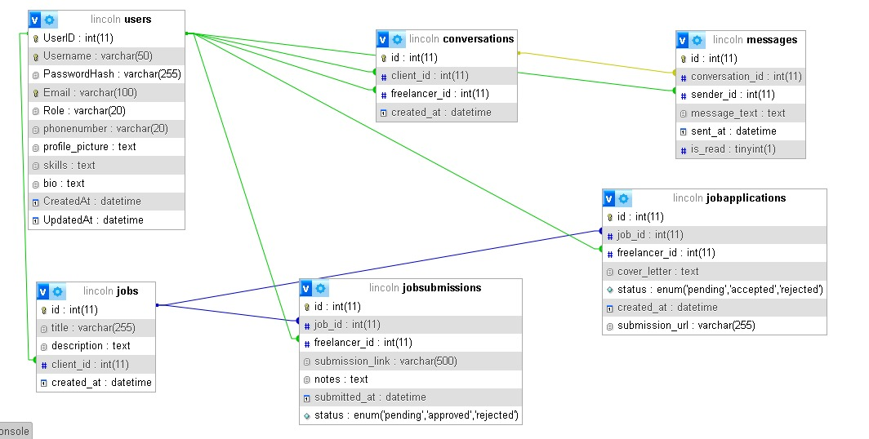**

**Chapter 4: Results & Discussion**

**Outcomes**

Fully functioning role-based freelance system

Successful login, job posting, bidding, and completion

Admin dashboard shows platform metrics

**Comparison**

Unlike Upwork, this platform is customizable, lightweight, and cost-efficient.

1. **Chapter 6: Conclusion & Future Work**

**Summary of Achievements**

The platform delivers a robust freelance ecosystem where users interact through job postings and applications, backed by role-based security and analytics.

**Potential Improvements**

Integrate secure payment gateways (e.g., PayPal, Stripe)

Introduce a recommendation engine using ML

**REFERENCES**

Fiverr. (2021). Trends in online freelancing: Opportunities and challenges. Retrieved from [https://www.fiverrinsights.com](https://www.fiverrinsights.com" \t "_new).